Title of your Project

Sienna Wylie

12

Avondale College

List standards completed with this project

Refer to your assignment document

Table of Contents
Introduction 1
Problem statement/Background/Research statement 1
Use case 1
GitHub link to your repository 1
Analysis 2
Stakeholders 2
End users 2
Possible solutions 2
Project schedule - timeline/plan 2
Cost vs Benefit Analysis 2
Design 3
Wireframes 3
Flowcharts/Pseudocodes 3
Use case diagram 3
Entity relationship diagram 3
Class diagram 3
Development 4
GitHub commits 4
Screen shots 4
Code comments and descriptions 4
Development stages - progress made should be visible 4
Implementation 5
Testing and Documentation 5
User Experience - End user considerations and stakeholders’ feedback 5
Test cases - check all options, boundary cases and error control/message 5
Documentation - explanation about your software, how it works, what are the key requirements etc (user manual or GitHub Readme.txt) 5
Relevant Implications - Address any five relevant implications. 6
Maintenance 7
Conclusion 7
References 7

Introduction

Problem statement/Background/Research statement
Problem
Airline databases may be complicated and hard to use, therefore making it harder to train employees to use them and harder to prove consistency.

Use case
Uses include a flight attendant will be able to check if all the meals required for the flight are stocked or a passenger assistant will be able to tell a passenger when their flight is taking off.

GitHub link to your repository
https://github.com/S-Wylie/12TPI

Analysis

Stakeholders
The Stakeholders are the higher-ups of Air New Zealand.

End users
Flight attendants, passenger assistants, airline reservation agents, flight attendants, air traffic controllers, and airport managers

Possible solutions
An airport tracking system. It will track planes, flights for those planes, passengers on those flights, classes for those passengers, meals for those passengers, and airports for the flights. This project will have the ability to hold a lot of information in an easy to read and understand format, making it more conventional than other airport databases.

Project schedule - timeline/plan

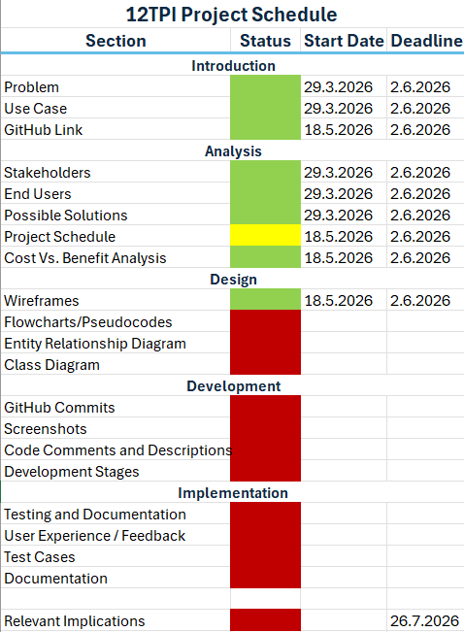

Cost vs Benefit Analysis
Costs:
- Expensive to set up and maintain
- Old employees have to be trained to use the new system – therefore halting the usage of the system and cost due to having to pay employees during training
Benefits:
- Easier for new employees to adapt to
- Consistency will be easier

Design

Wireframes
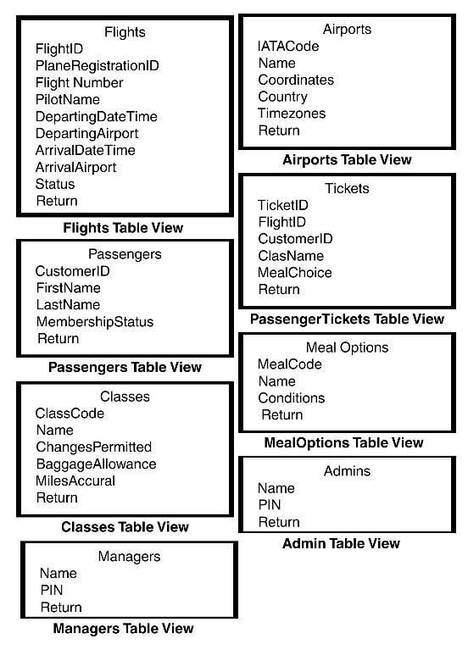
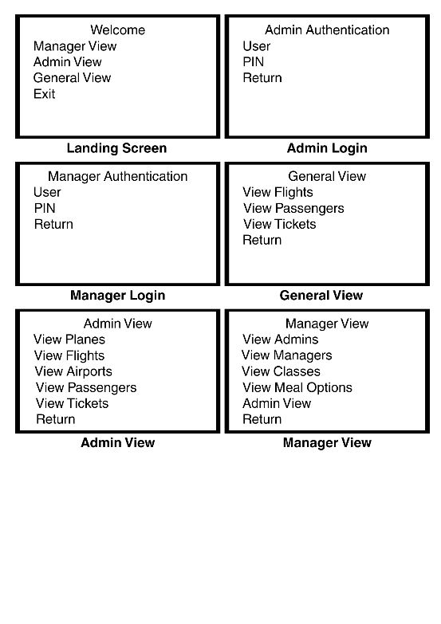

Flowcharts/Pseudocodes
Landing Screen
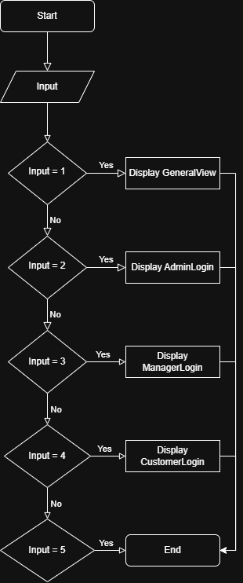
Admin Login

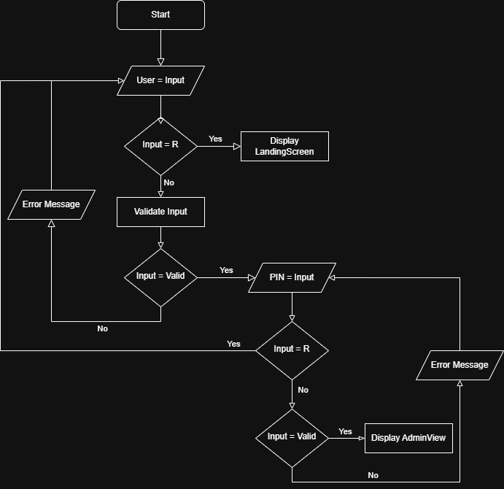
Manager Login

Use case diagram

Entity relationship diagram

Class diagram
V1
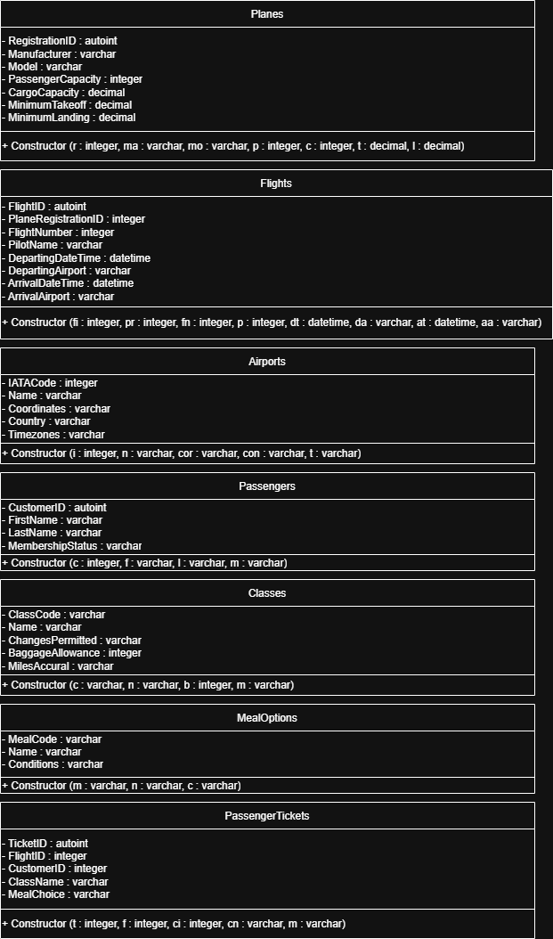
V2

Development

GitHub commits

Screenshots

Code comments and descriptions

Development stages - progress made should be visible

Implementation

Testing and Documentation

User Experience - End user considerations and stakeholders’ feedback

Test cases - check all options, boundary cases and error control/message

Documentation - explanation about your software, how it works, what are the key requirements etc (user manual or GitHub Readme.txt)

Relevant Implications - Address any five relevant implications.
Do not just explain, instead provide justifications on how you are addressing them: social, cultural, legal, ethical, intellectual property, privacy, accessibility, usability, functionality, aesthetics, sustainability and future proofing, end-user requirements, health and safety.

Maintenance
Future directions - explain what was planned and whether it was achieved or not, if not then what can be done in future to improve the software

Any bugs that has not been resolved and what/how it can be solved

Conclusion

References

